Lent campaign:
Together for the common good

For over 50 years, congregations and Catholic schools across the country have brought our Lent campaigns to new heights. During this year`s Lent, you can help families facing starvation due to climate change. But what happens to the money you pledge or transfer to Caritas? You can learn more about where your donation goes here.

- “It is fantastic to see the commitment and the joy of giving we experience during our Lent campaigns year after year. It is a huge inspiration, and the income from the campaigns is very important for our long-term relief work in Africa, Asia and Latin America” - Martha Rubiano Skretteberg, Secretary General, Caritas Norway

Last year, the campaign’s supporters donated a total of NOK 1,889,749. That is the best result we have ever had.

You can make a difference

This year's Lent campaign has been named "Together for the common good".

- During Lent, we can reduce our consumption, show moderation, give to our neighbor, and at the same time, help thousands of people out of hunger. It often does not take much. A vegetable garden for a family in Africa or Asia does not cost more than what we would spend on a garment or to go out for hamburgers in the city. Reducing our consumption here in the West is helping to reduce CO2 emissions and global warming. If we also give some of what we save from eating less meat or buying fewer things, we can help some of the people suffering the most by climate change. With training in agricultural techniques that provide increased crop turnover even in unpredictable weather conditions, they will manage to provide enough food for themselves and their families and do not have to flee, says Skretteberg.

Increased world hunger

One of the UN's sustainability goals is to eradicate world hunger by 2030. We all have a shared responsibility in achieving this goal. But unfortunately, our progress made in the last years, has taken a wrong course. Today, 811 million people suffer from chronic hunger, while 283 million people are at acute risk of dying from food shortages. (WFP)

One of the main causes of hunger is climate change. Climate change in the form of extreme weather, droughts and floods affects all parts of the world, but the poorest are hardest hit. The challenges are evident in large parts of sub-Saharan Africa. Millions of small-scale farmers live on the front lines of climate change, and every year have their crops destroyed due to prolonged droughts or too much rain. To avoid starvation, many leave their homes in search of more promising opportunities.

It helps to help

-Fortunately, it helps to help. We see that eight out of ten families who participate in our projects increase their income by 30 percent and go from one to three meals a day. In addition to their increased living standards, we see that more families can afford to send their children to school. We need your help to ensure that more people in the world have access to food, says Martha R. Skretteberg.
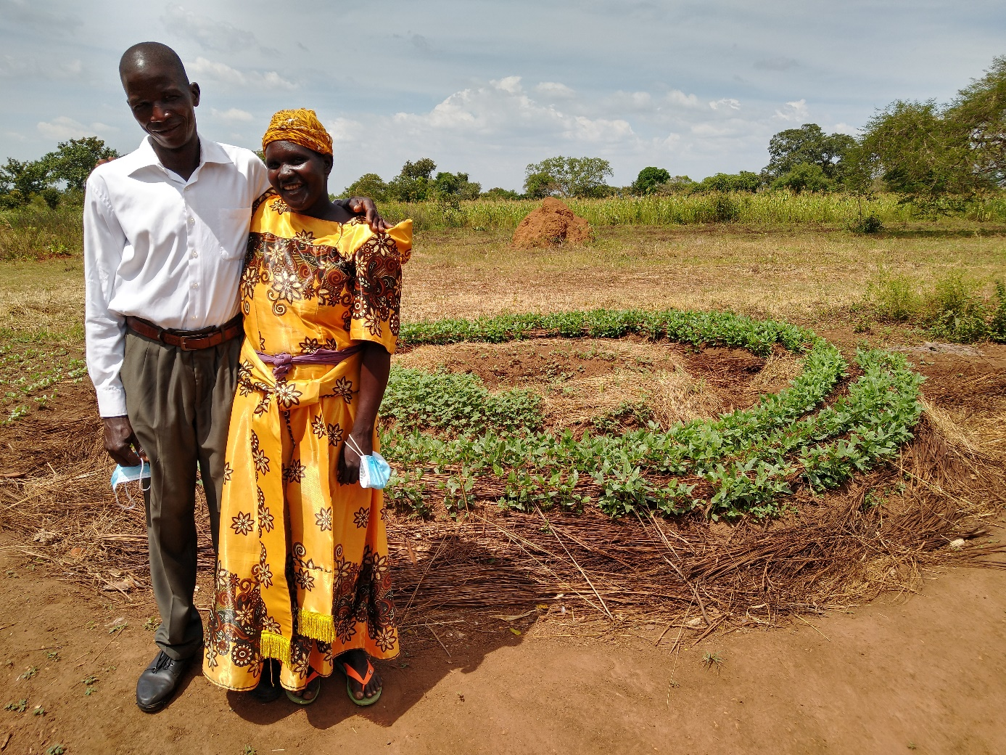

Uganda: From one to three meals per day
Jenet Aghma participates in Caritas' food safety program in Lira, Uganda. Here she is standing with her husband Agama Bosco in front of her Mandala-vegetable Garden. It is covered with straw and designed to better withstand droughts and heavy rain showers. Jenet has received training in climate-adapted agriculture, which has contributed to her increased number of crops. It has allowed her to be able to invest in a cow and a motorcycle and make improvements to the house they live in. Before, the family ate one meal a day, while now they eat three. Jenet wants to continue with agriculture and to be able to give her eight children an education. Neither she nor her husband were allowed to go to school.

